Software Testing Assignment -1

1) What is SDLC?

The software development life cycle (SDLC) is a structured process that enables the production of high-quality, low-cost software, in the shortest possible production time

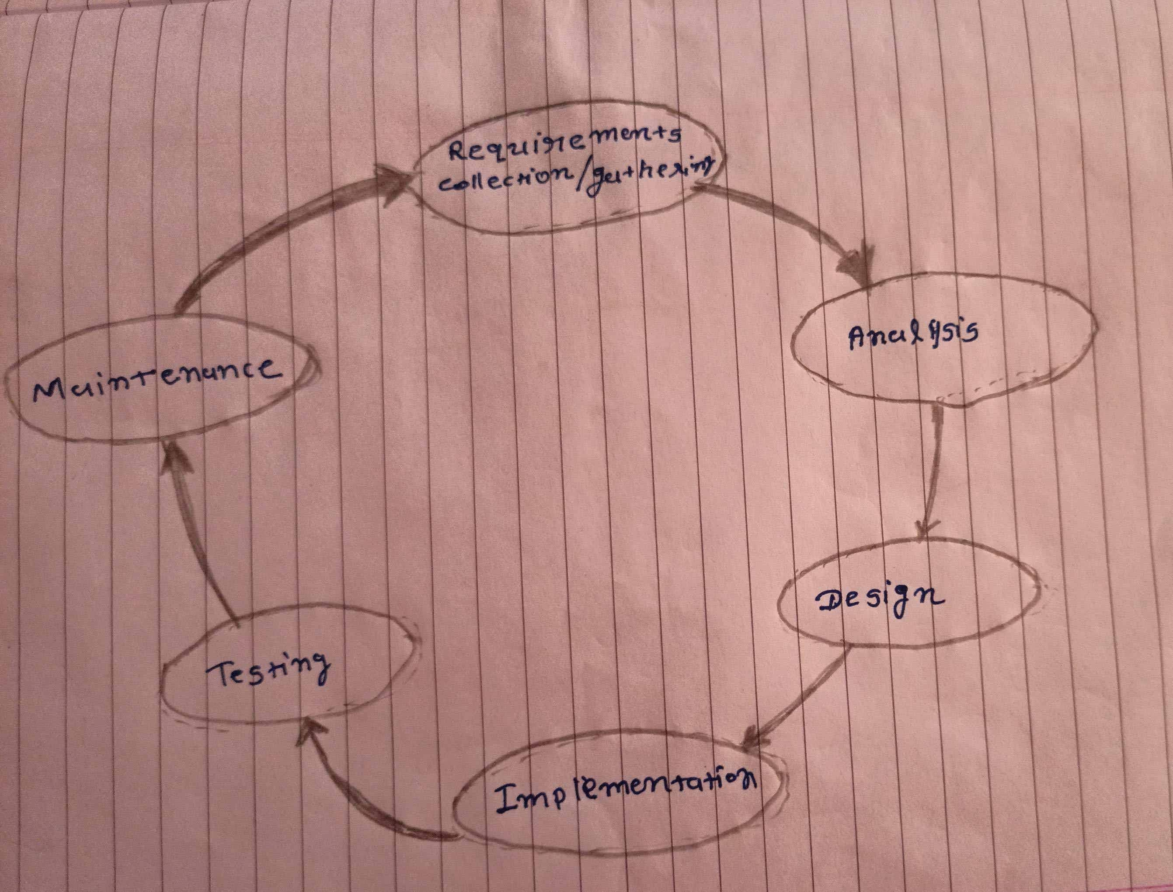

**2) What is agile methodology?**

Agile Methodology meaning a practice that promotes **continuous iteration** of development and testing throughout the software development lifecycle of the project. In the Agile model in software testing, both development and testing activities are concurrent, unlike the Waterfall model.

 Agile methodologies propose incremental and iterative approach to software design

**3) What is SRS?**

Software Requirements Specification is a complete description of the behavior of the system to be developed.

A software requirements specification (SRS) is a document that describes what the software will do and how it will be expected to perform. It also describes the functionality the product needs to fulfill all stakeholders (business, users) needs.

**4) What is oops?**

Object-oriented programming is based on the concept of objects. In object-oriented programming data structures or objects are defined, each with its own properties or attributes. Each object can also contain its own procedures or methods.

**5) Write basic concepts of oops.**

1) Object

2) Class

3) Encapsulation

4) Inheritance

5) Polymorphism

5.1) Overriding

5.2) Overloading

6) Abstraction

**6) What is object?**

An object is the instance of the class, which helps programmers to use variables and methods from inside the class.

Object acts like a variable of the class.

**7) What is class?**

A class is a blueprint from which you can create the instance, i.e., objects.

A class is used to bind data as well as methods together as a single unit.

A class doesn't take any memory spaces when a programmer creates one.

The class has to be declared only once.

**8) What is encapsulation?**

Encapsulation is the practice of including in an object everything it needs hidden from other objects. The internal state is usually not accessible by other objects.

Encapsulation in Java is the process of wrapping up of data (properties) and behavior (Methods) of an object into a single unit.

**9) What is inheritance?**

Inheritance means that one class inherits the characteristics of another class. This is also called a “is a” relationship

Inheritance describes the relationship between two classes. A class can get some of its characteristics from a parent class and then add unique features of its own.

In general, Java supports single-parent, multiple-children inheritance and multilevel inheritance (Grandparent-> Parent -> Child) for classes and interfaces. Java supports multiple inheritances (multiple parents, single child) only through interfaces.

**10) What is polymorphism?**

Polymorphism means “having many forms”.

It allows different objects to respond to the same message in different ways, the Response specific to the type of the object.

There are two types of polymorphism in Java

1) Compile time polymorphism (Overloading)

2) Runtime polymorphism (Overriding)

**11) What is RDBMS?**

**12) What is SQL?**

**13) Write SQL Commands**

**14)Draw Use case on online book shopping**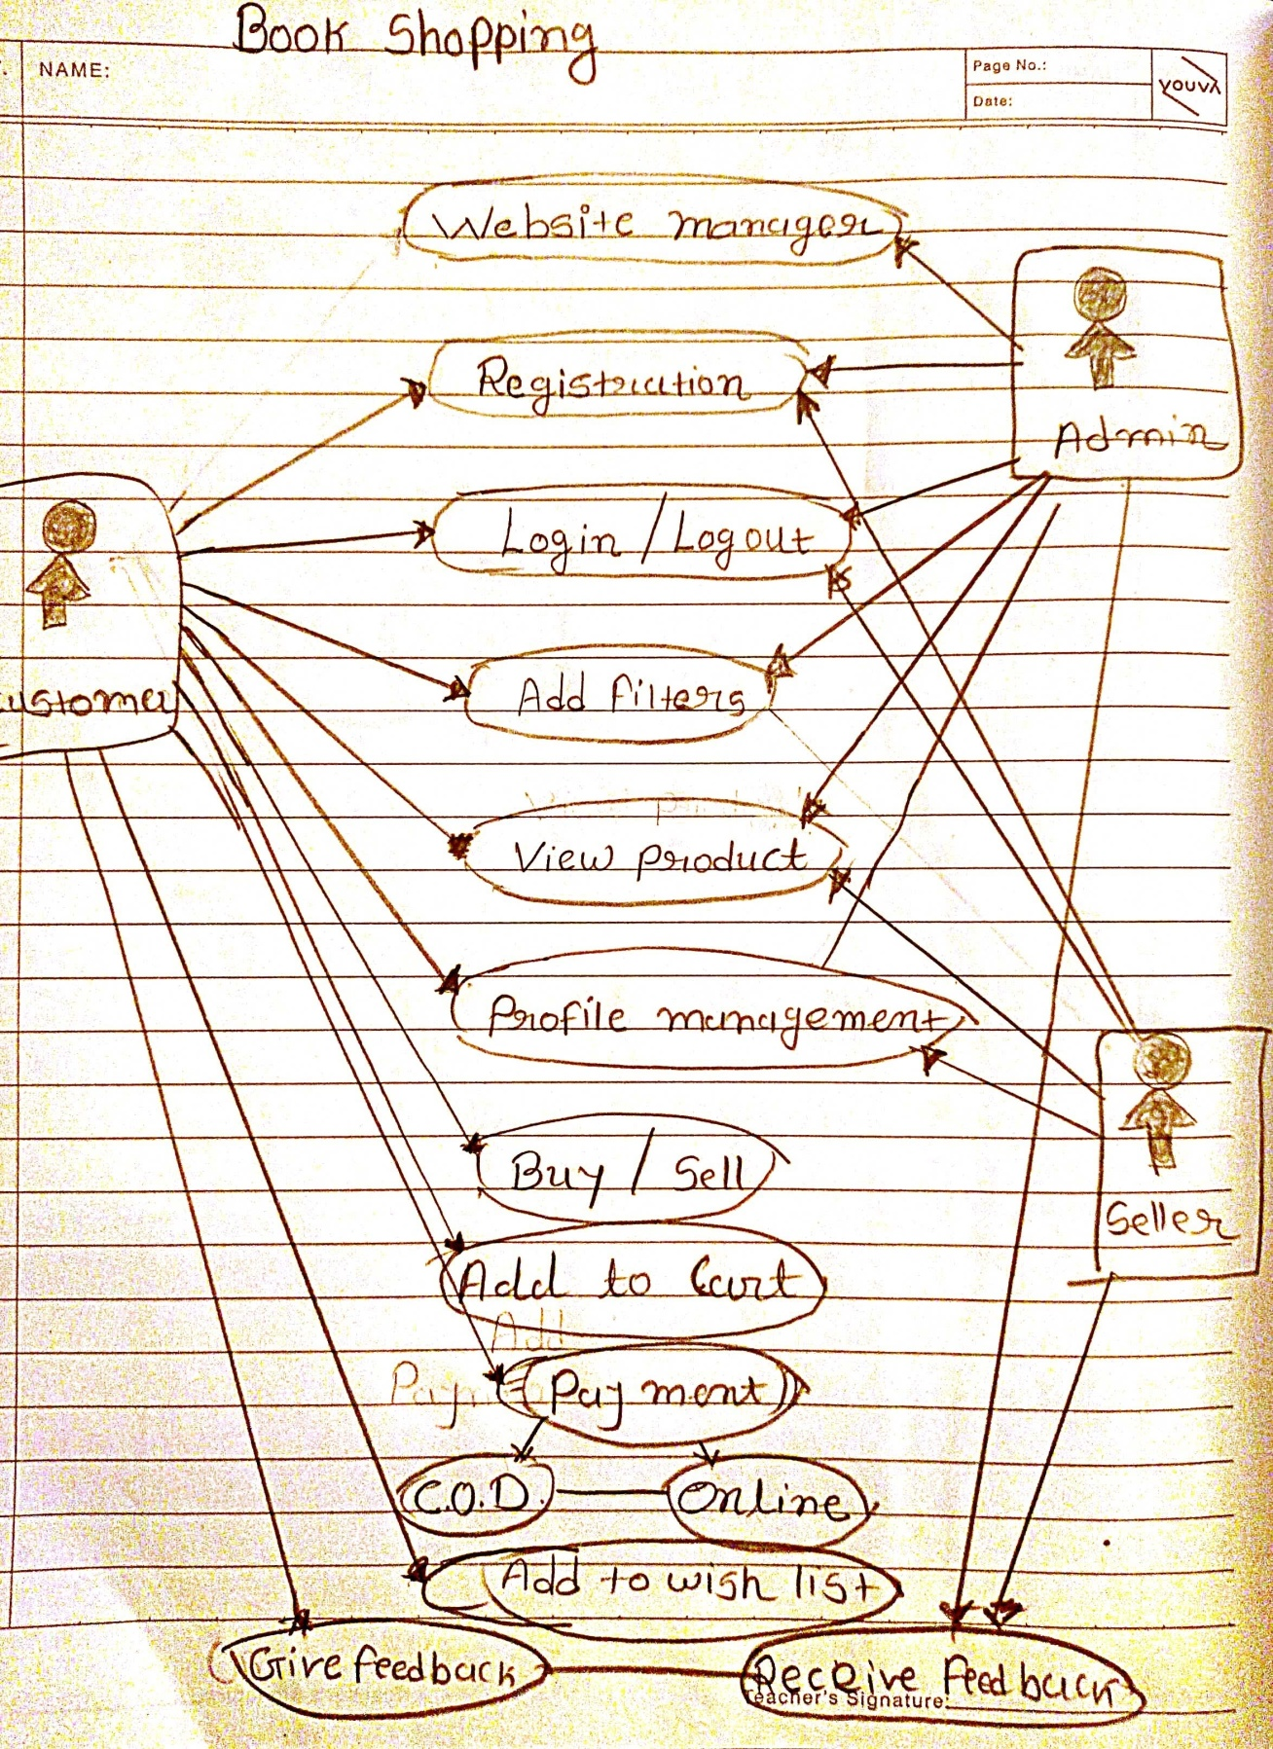

**15) Draw Use case on online bill payment system (pay tm)**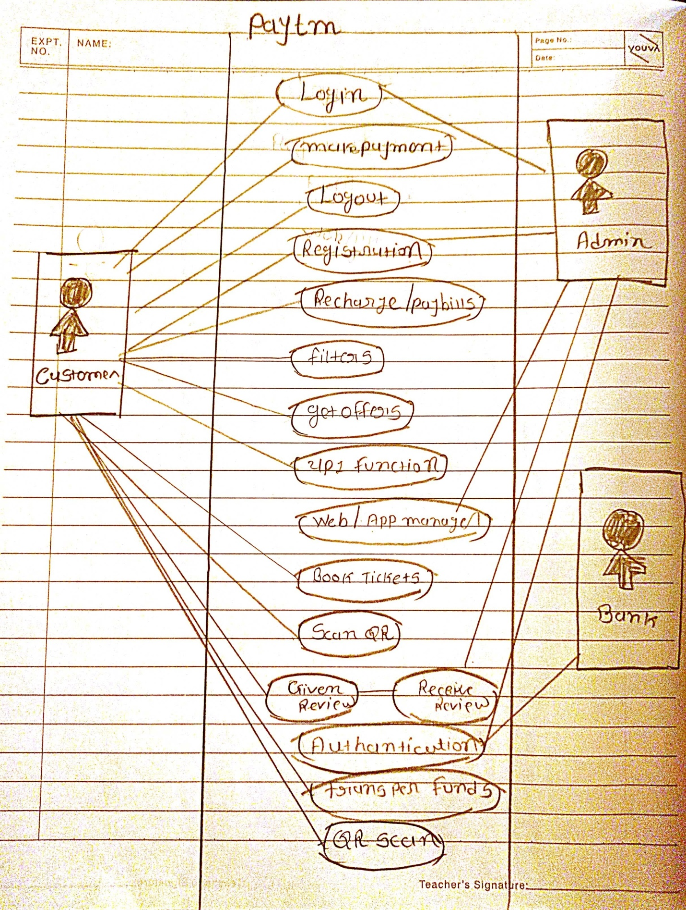

**16) Write SDLC phases with basic introduction**🡪

**1) Requirements Collection/Gathering**:🡪 Requirements gathering is the process of determining what your projects need to achieve and what needs to be created to make that happen.

**2) Analysis:🡪** the analysis phase is where multiple collected and processed items are examined, correlated, and given the necessary context the make them useful.

**3) Design**:🡪 The purpose of the Design Phase is to transform the requirements into complete and detailed system design specifications. Once the design is approved, the Development Team begins the Development Phase.

**4) Implementation**:🡪 The implementation phase involves putting the project plan into action.

**5) Testing**:🡪  where you focus on investigation and discovery, during the testing phase

**6) Maintenance**:🡪Software maintenance is a part of Software Development Life Cycle. Its main purpose is to modify and update software application after delivery to correct faults and to improve performance.

**17) Explain Phases of the waterfall model**

**1) Requirements**: The first phase involves understanding what needs to design and what is its function, purpose, etc. Here, the specifications of the input and output or the final product are studied and marked.

**2) System Design**: The requirement specifications from the first phase are studied in this phase and system design is prepared. System Design helps in specifying hardware and system requirements and also helps in defining overall system architecture. The software code to be written in the next stage is created now.

**3) Implementation**: With inputs from system design, the system is first developed in small programs called units, which are integrated into the next phase. Each unit is developed and tested for its functionality which is referred to as Unit Testing.

**4) Integration and Testing**: All the units developed in the implementation phase are integrated into a system after testing of each unit. The software designed, needs to go through constant software testing to find out if there are any flaws or errors. Testing is done so that the client does not face any problem during the installation of the software.

**5) Deployment of System**: Once the functional and non-functional testing is done, the product is deployed in the customer environment or released into the market.

**6) Maintenance**: This step occurs after installation, and involves making modifications to the system or an individual component to alter attributes or improve performance. These modifications arise either due to change requests initiated by the customer, or defects uncovered during live use of the system. The client is provided with regular maintenance and support for the developed software.

**18) Write phases of spiral model**

The spiral model has four phases: **Planning, Design, Construct and Evaluation**

**19) Write agile manifesto principles**

Every process model has its manifesto so does the agile model. The four-core value of the agile manifesto is:

Individual creativity and interactions among the group over the process and tools are more effective.

Working software is the actual product, not the accompanying comprehensive documentation.

Collaboration of client and developer over the contract must be a healthy way.

Responding to the changes requested by the client over the following plan

**20) What is join?**

**21) Write type of joins.**

**22) Explain working methodology of agile model and also write pros and cons.**

Deffination: Agile methodology is an iterative and incremental approach to software development.

Following are the advantages of agile methodology-

Agile is very much suited for projects where requirements and the end product is not very clear.

It promotes customer satisfaction as their feedbacks and changes are embraced.

It reduces risk factors as early deliverables are made visible to the end-users.

Exhaustive planning is not required at the beginning of the development process.

It is easy to manage with minimal rules and more flexibility.

Dividing the project into incremental deliverable builds leads to more focus on the quality of the product.

Following are the disadvantages of Agile methodology-

As it is highly customer-centric, so it can pose a problem when the customer does not have a clear understanding of the product and process.

Lack of formal documentation and designing leads to a very high dependency on individuals for training and other tasks.

For complex projects, the resource requirement and effort are difficult to estimate.

Frequent deliverables, feedback, and collaboration can be very demanding for some customers.

Because of the ever-evolving features, there is always a risk of the ever-lasting project.

**23)Draw use case on Online shopping product using COD.**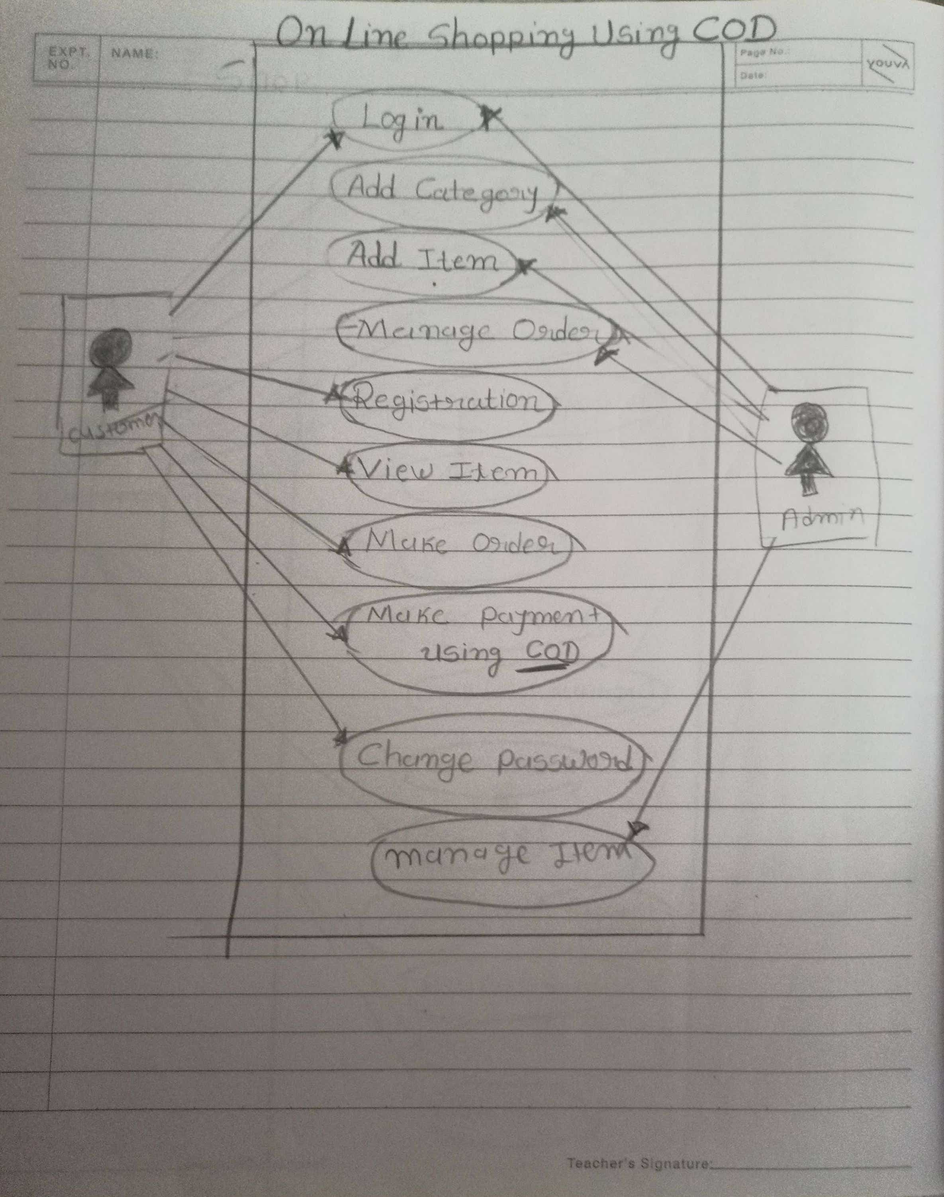

**24) Draw use case on online shopping product using payment gateway.**

